Lab Plan – 4: Flutter Layout Alignments and Widgets
Objective:
The objective of this lab is to understand and implement Flutter layout widgets i.e. Row alignments, Column alignments, Container usage, Center widget, and applying Padding to design responsive and well-structured UIs.

Task 1: Create a Flutter Project
- Open VS Code or Android Studio.
- Use shortcut:
Ctrl + Shift + P → Flutter: New Project (for VS Code).
- Name your project lab_plan_4 and set up the folder location.

Task 2: Add an AppBar with Centered Text
- Create a Stateless Widget using shortcut stle.
- Inside Scaffold, add an AppBar.
- Use centerTitle: true to align the text in the center.
- Add font size, font weight, and style to the AppBar title.

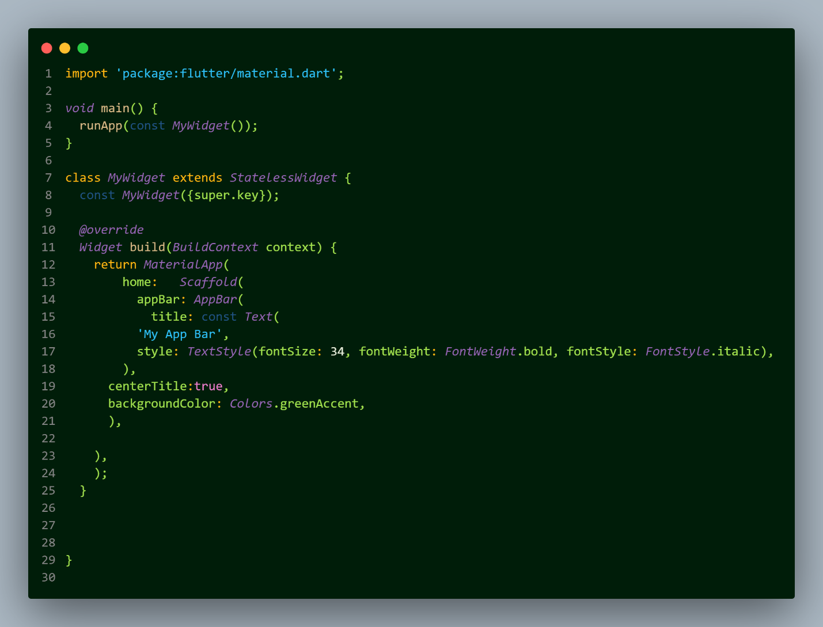

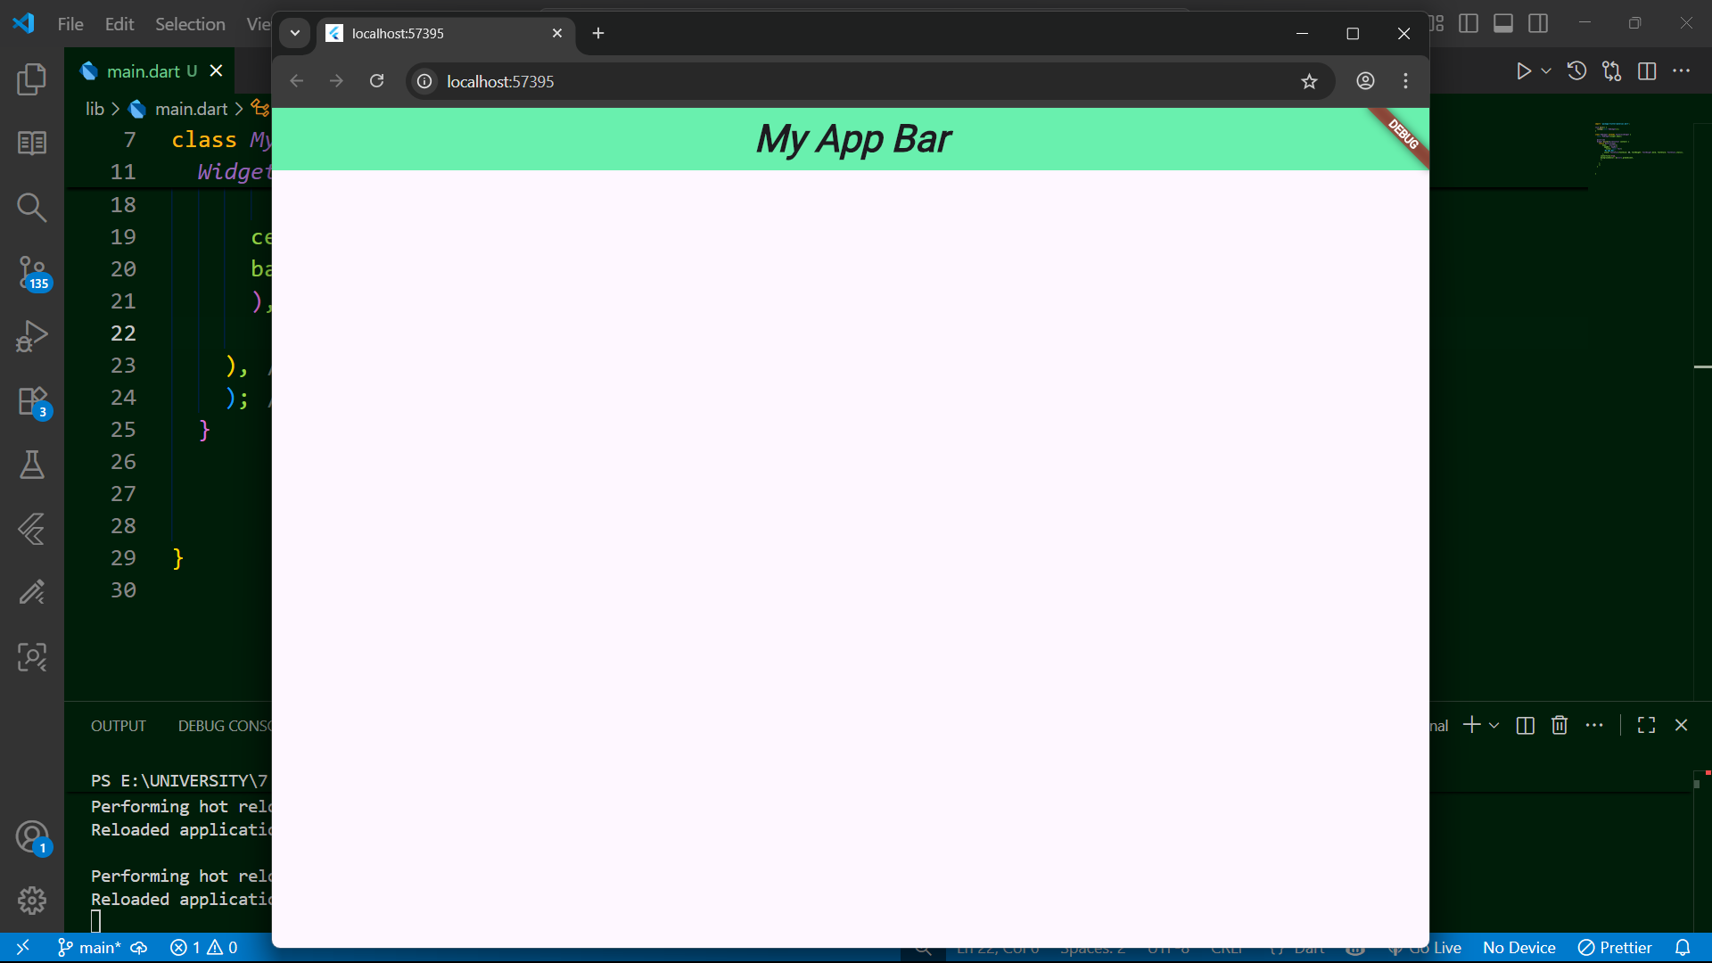

Task 3: Container Usage
- Add a Container widget at the body
- Apply properties:
  - color
  - height and width
  - margin
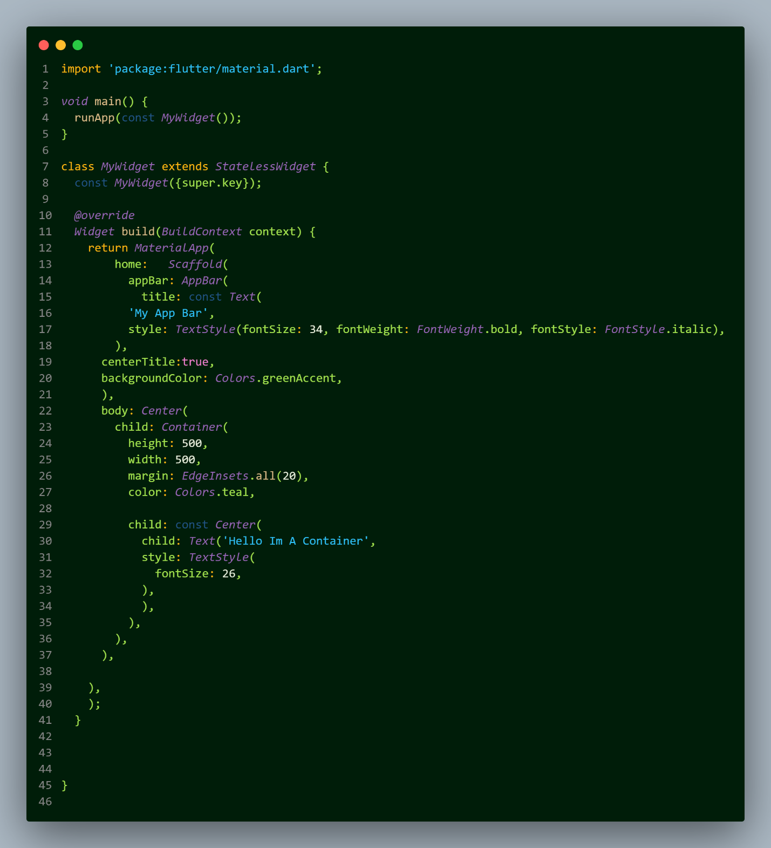

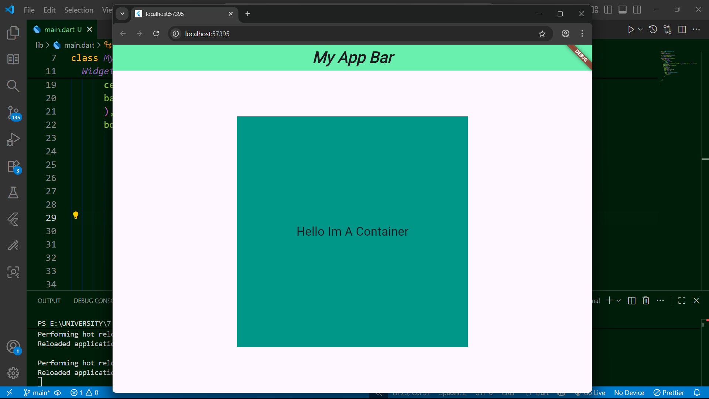

Task 4: Row Alignments
- Create a Row widget inside Scaffold’s body.
- Use mainAxisAlignment and crossAxisAlignment properties to align children.
- Example alignments to try:
  - MainAxisAlignment.start
  - MainAxisAlignment.center
  - MainAxisAlignment.spaceEvenly
  - CrossAxisAlignment.start / CrossAxisAlignment.end

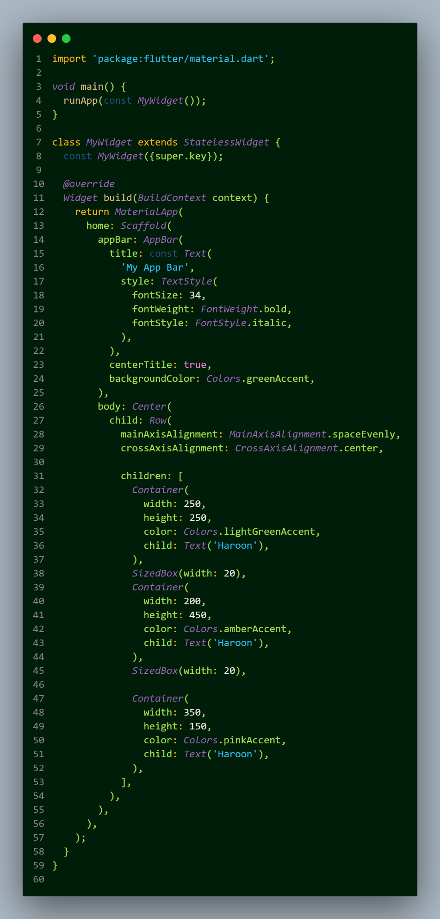

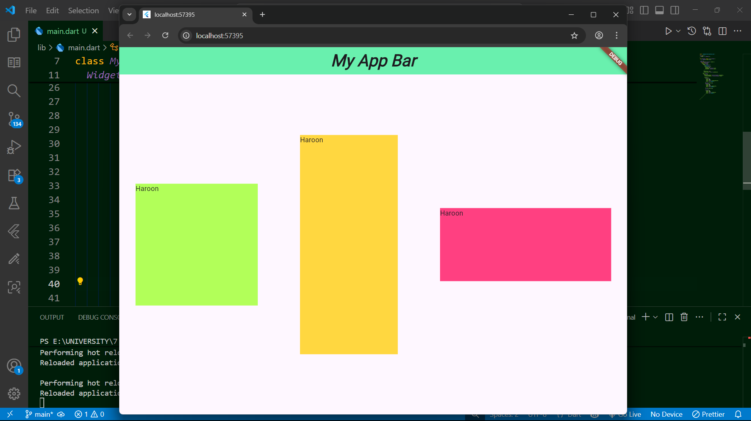

Task 5: Column Alignments
- Create a Column widget inside Scaffold’s body.
- Experiment with vertical alignment:
  - MainAxisAlignment.spaceAround
  - MainAxisAlignment.center
  - MainAxisAlignment.end
- Experiment with horizontal alignment using crossAxisAlignment.

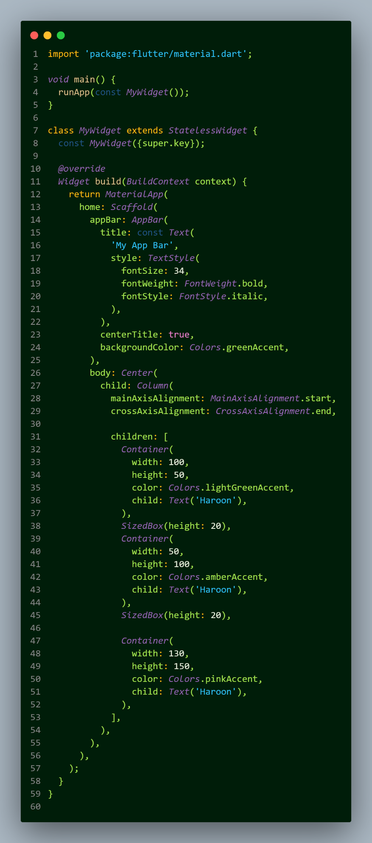

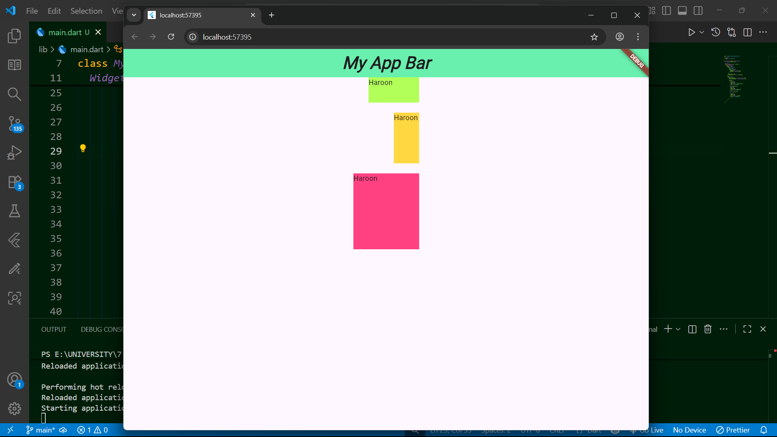

Task 6: Center Widget
- Wrap a widget (like Text or Container) with Center widget.
- Observe how it automatically positions the widget in the middle of available space.

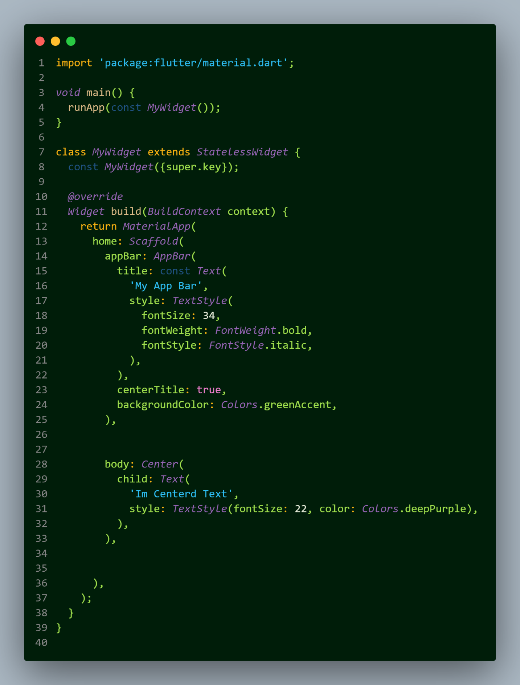
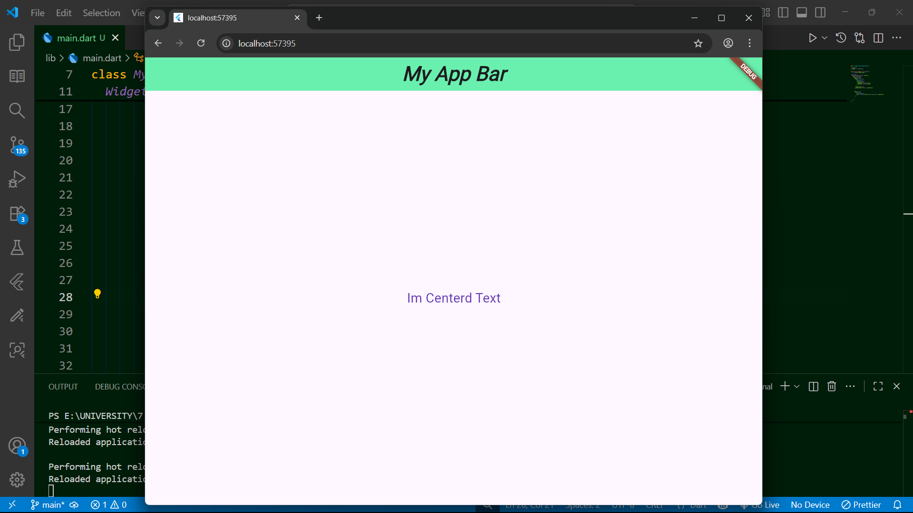

Task 7: Padding on Screen
- Use the Padding widget to add space inside the layout.
- Apply different padding styles:
  - EdgeInsets.all(20)
  - EdgeInsets.symmetric(horizontal: 30, vertical: 10)
  - EdgeInsets.only(left: 15, top: 40)
